Temporary addendum to AA 3120700 for welding of aluminium-copper cascades at project B9

Latest amendment
Point 1 changed and formatting revised.

Purpose
These work instructions describe the special procedures and specifications for welding aluminium-copper cascades for project B9.
This addendum applies in addition to the customer specifications:
KR-AU-EE2-29
VW 60307-2
This work instruction remains valid as long as the generally valid adjustment in AA 3.12.07.00 has not yet been released and thereby replaces this work instruction.

Applicable area
This work instruction applies in all plants where QMH 1.00.00.00 is valid. Temporarily and exclusively valid for project B9.

Terms, abbreviations
Not documented

Responsibilities
Responsible is the local industrial engineering.

Flow description

Important notes
It is imperative to observe the requirements of the following standards with regard to the length of the wiring between the US welding node and the contact attached to the wiring:
- VW 75147
- DB A 009 000 02 99
- Tyco TE 114-18022
- Further requirements of applicable specifications, supplier and customer standards
If the requirements cannot be met, special measures, such as welding first and then crimping, or other connection techniques must be used.

General definitions
When welding alu-copper cascades, the copper wire must always be inserted on the sonotrode side. The aluminum wire is thus on the anvil side. Only one wire is permitted on each side (parallel splice) per knot. This means each splice consists of two wires.
In the first welding step, the copper wire and in the second welding step the aluminum wire must be inserted centered between the slide and surface plate. The wires should neither touch the surface plate (shown on the right in the picture) nor the slide (shown on the left in the picture) prior to welding.

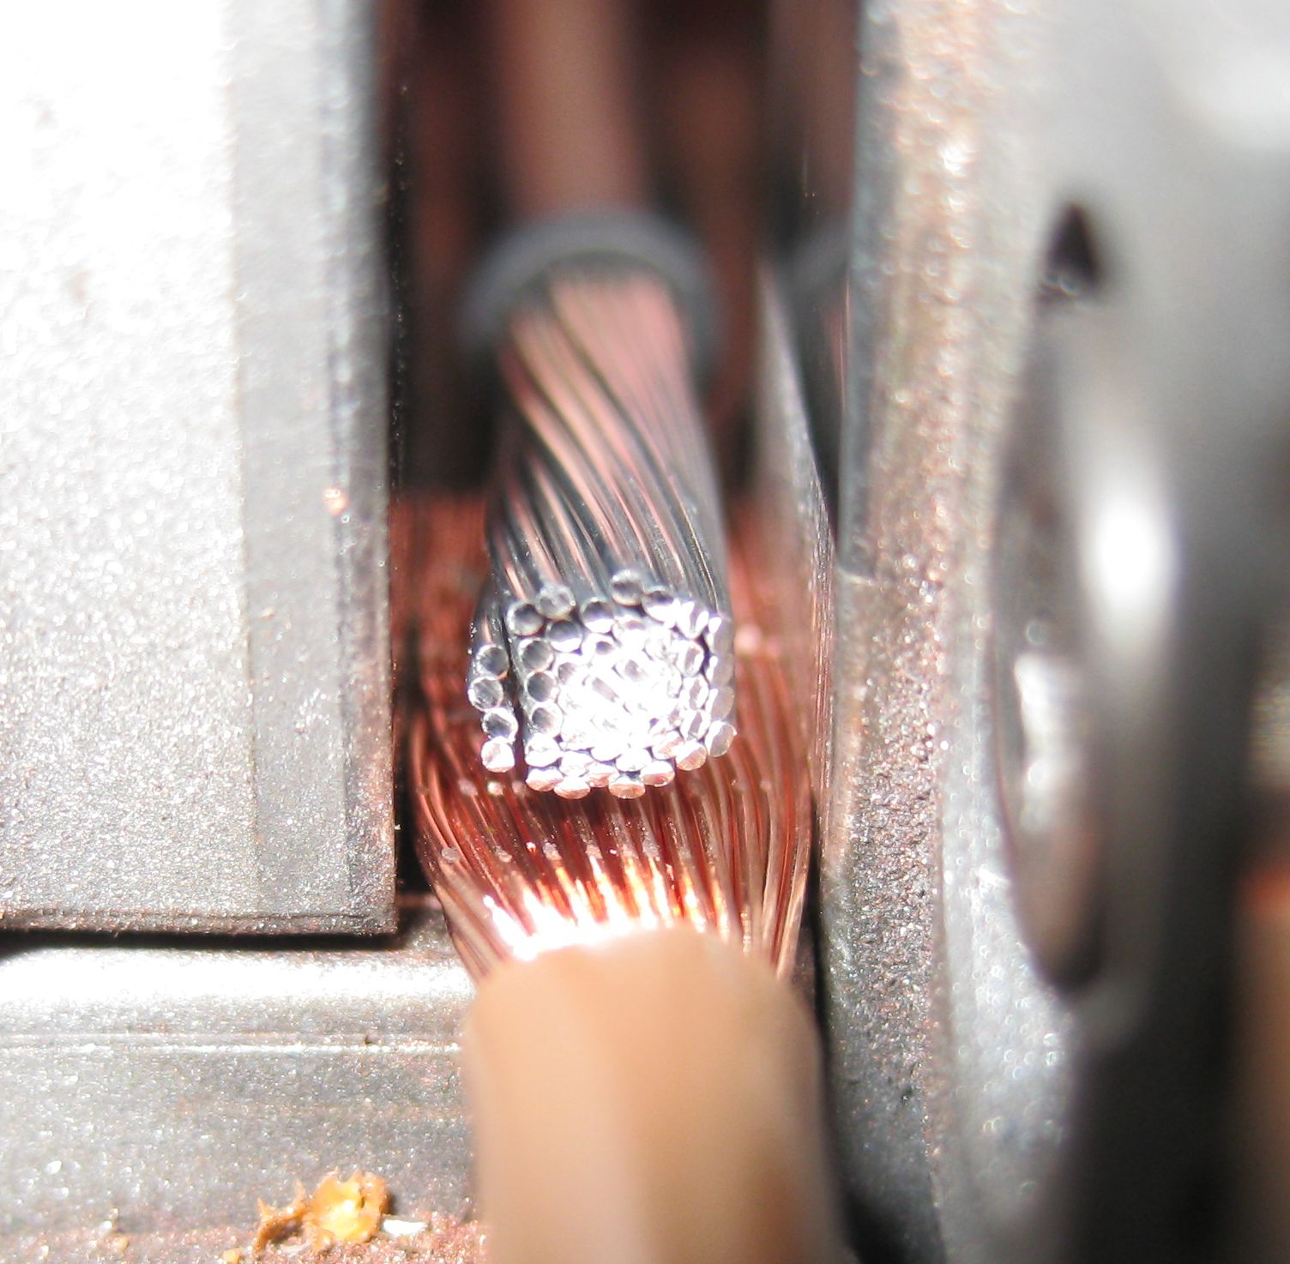
The distance between slide and wire and the
distance between surface plate and
wire should be identical.

Definitions for the machine
At present, the following specifications for welding the following alu-copper cascades are approved:
- GS40: Cascade 16mm² Alu + 10mm² Cu
Cascade 10mm² Alu + 6mm² Cu
Cascade 6mm² Alu + 4mm² Cu
Cascade 4mm² Alu + 2,5mm² Cu
Cascade 2,5mm² Alu + 1,5mm² Cu
- LS60: Cascade 40mm² Alu + 25mm² Cu
Cascade 40mm² Alu + 16mm² Cu
Cascade 25mm² Alu + 16mm² Cu

To weld the alu-copper cascades, the software for the two-step welding must be installed and activated. During two-step welding, the copper wire is pre-compacted and the aluminum wire is welded on in the second step. This prevents the aluminum wire from being positioned on the sonotrode.

In addition, special welding tools must be used for aluminum. Here the surfaces of the slide and surface plate facing the splice are coated. This prevents the aluminum from sticking to the slide or surface plate.
In addition, the tools have a hold-down. When the cascade is welded, the aluminum wire in the splice is extended lengthwise in the direction of the splice. The hold-down is used to hold down the extending aluminum wires.

Dimensions
The distance of the single strands to the insulation of the opposing wire in the splice must be at least 1mm.

Peel strength test
To perform a peel strength test, in spite of the composition of the splice it is necessary to weld the cascade as an end knot with two wires on one side. The peel strengths may not be less than the minimum strengths below.

Conductor nominal cross section aluminum [mm²] | Conductor nominal cross section copper [mm²] | Minimum peel strength [N]
2,5 | 1,5 | 15
4 | 2,5 | 25
6 | 4 | 50
10 | 6 | 70
16 | 10 | 80
25 | 16 | 100
40 | 16 | 100
40 | 25 | 100

Pull strength test
To perform a pull strength test, the splice must be produced as a parallel splice. The pull strengths may not be less than the minimum strengths below.

Conductor nominal cross section aluminum [mm²] | Conductor nominal cross section copper [mm²] | Minimum pull strength [N]
2,5 | 1,5 | 125
4 | 2,5 | 225
6 | 4 | 350
10 | 6 | 600
16 | 10 | 800
25 | 16 | 1000
40 | 16 | 1100
40 | 25 | 1200

Process capability
The required limit for the cmk is 1,67. The cmk`s is calculated regardless of the sample distribution on the basis of VW 10130 section 3.2.2 " Determining capabilities with undefined distribution models".

Splice insulation
A cascade must always be sealed. A heat shrink sleeve with inner adhesive according to TL82324 must be used.

Documentation, records
Not documented

Other relevant documents
Supplier and customer standards

